Testing

**Use Case 1: Register user**

For testing registering a user we have to see how it will respond to invalid input while registering. The invalid input includes leaving a field blank and creating a password that is less than 7 characters long. To test this we must test how the code reacts to each field being blank individually.

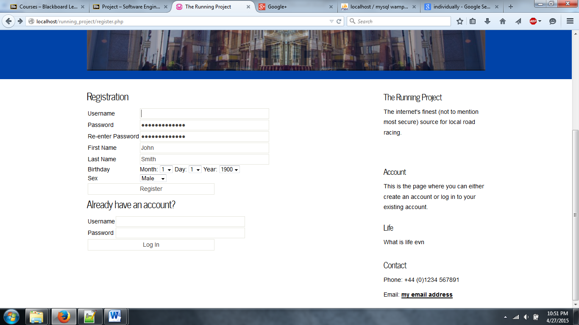

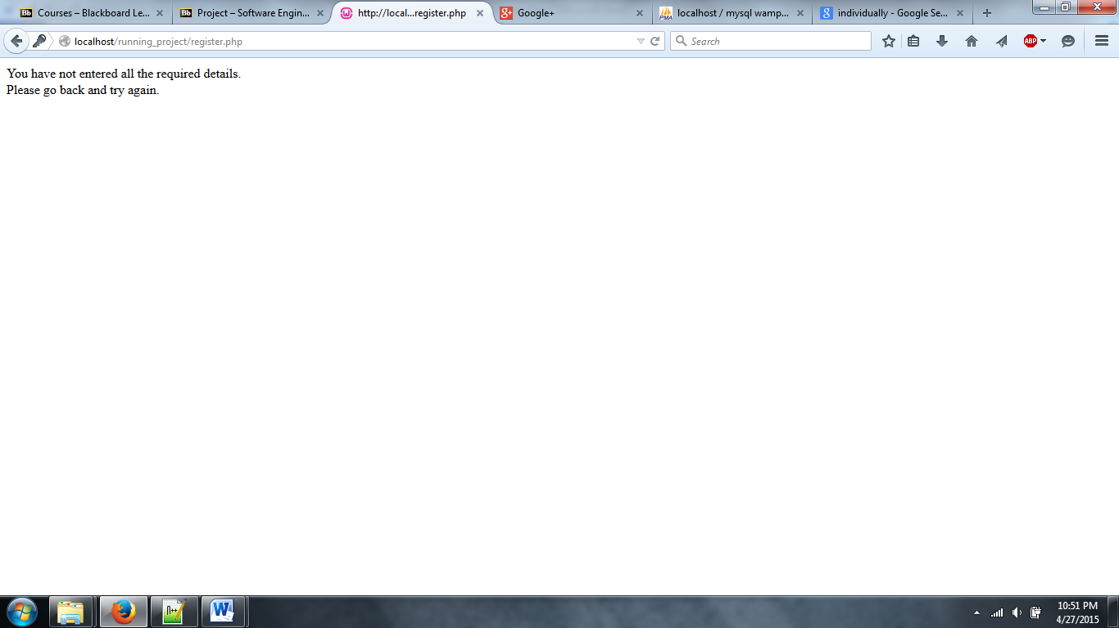

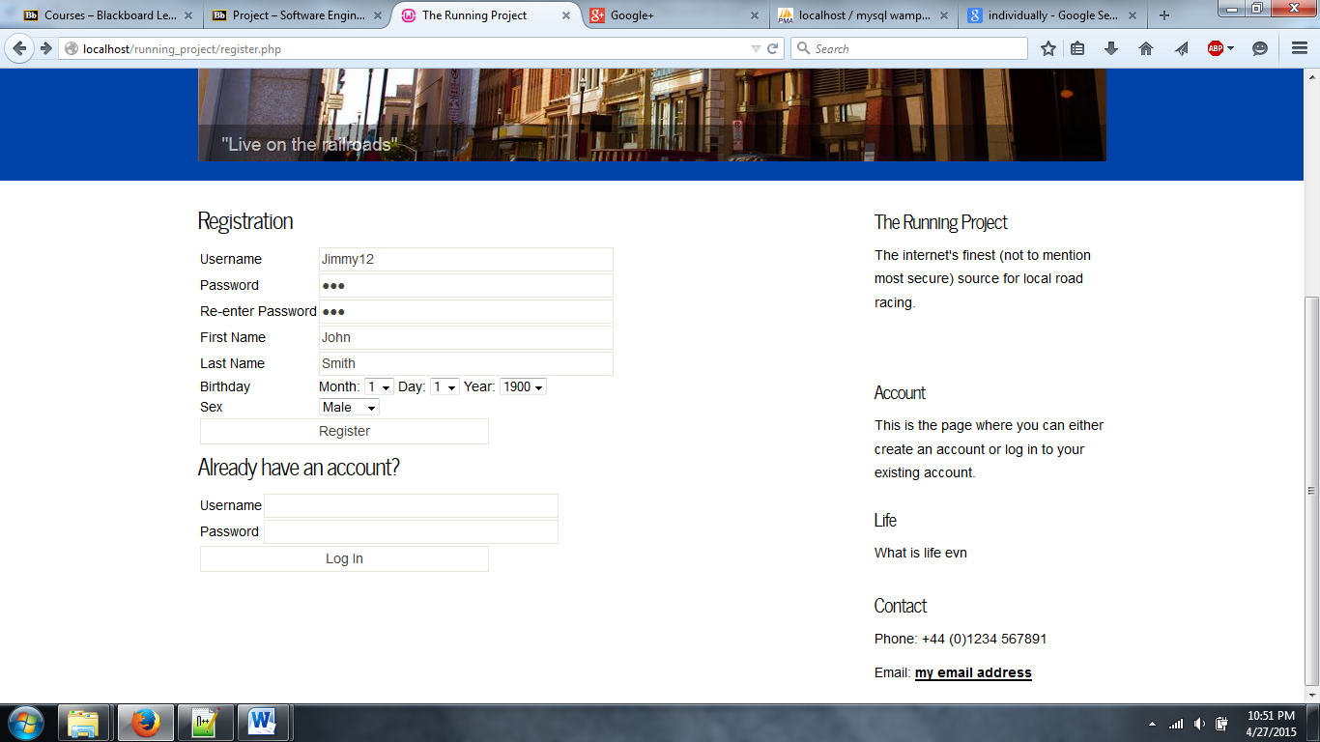

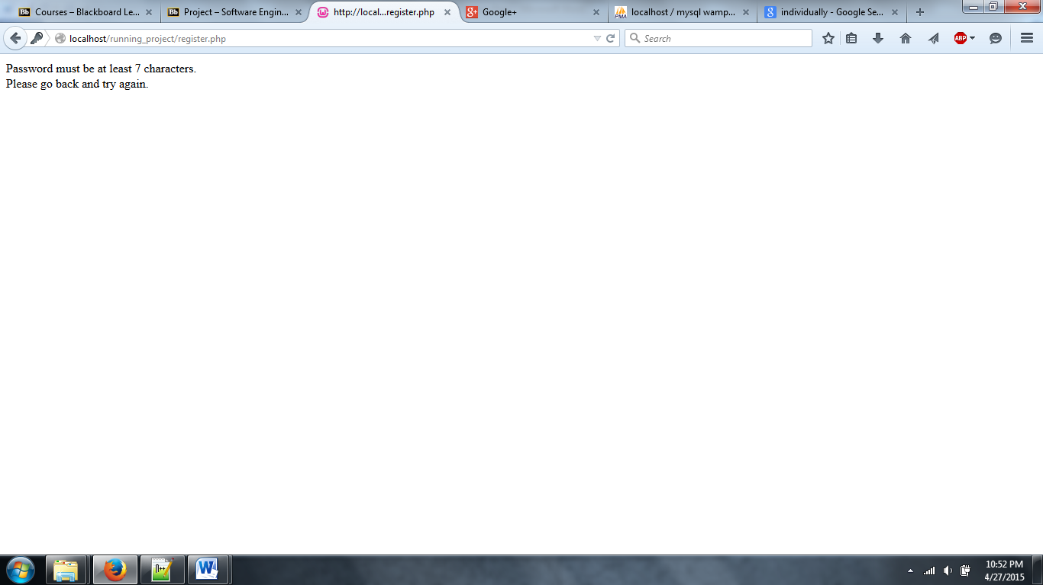

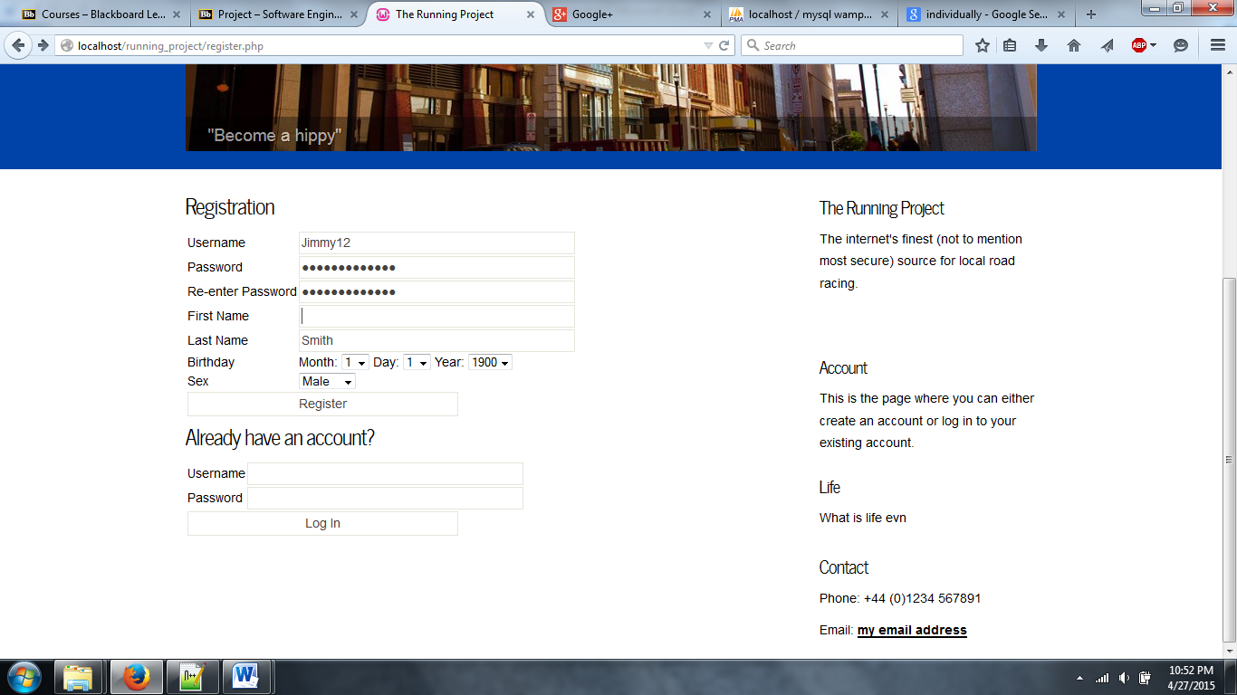

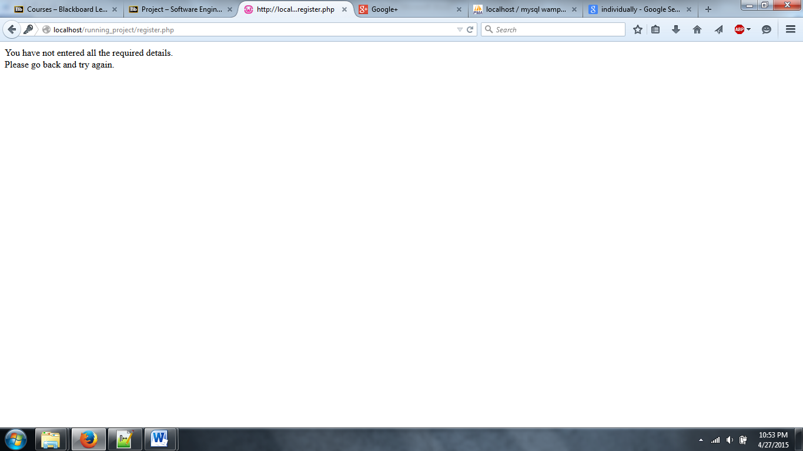

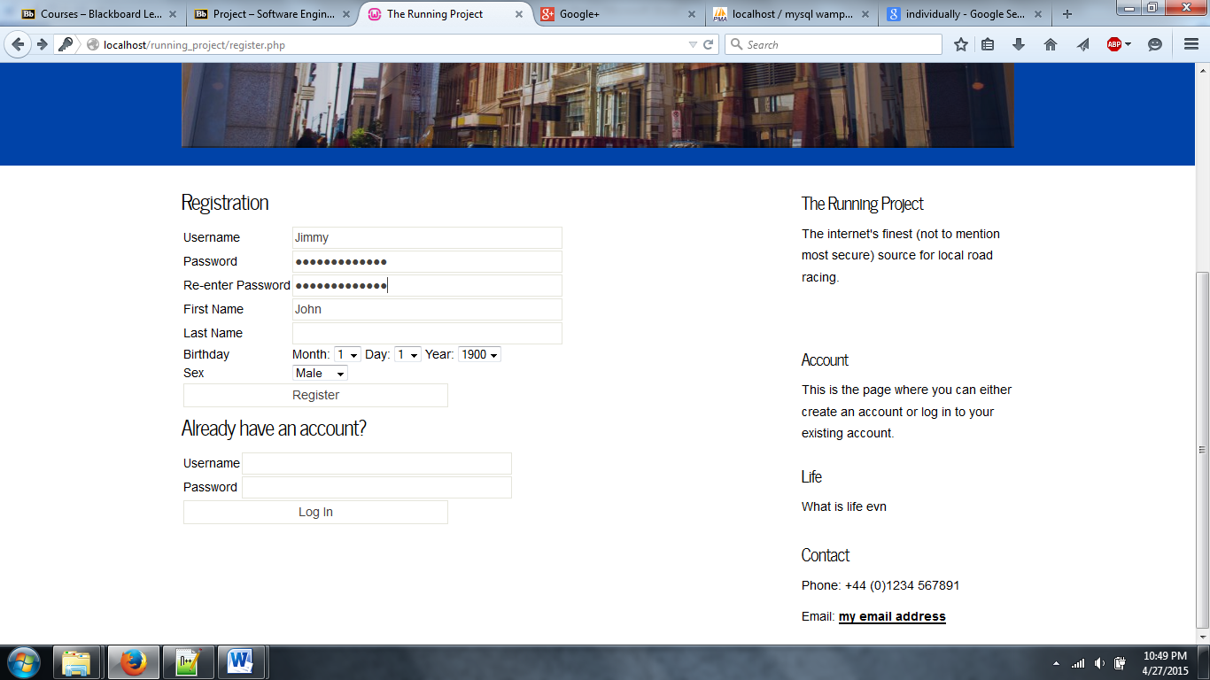

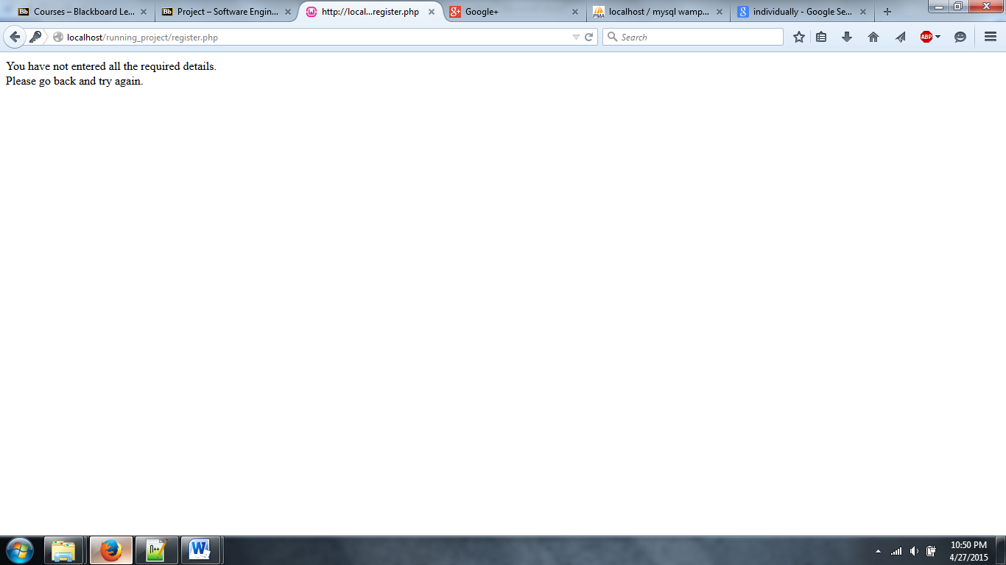

As you can see all the possible failures the system catches for the user and tells them their information is wrong.

**Use Case 2: Edit user**

Similarly for edit we have to test how all the fields can be wrong and if the system catches it. We also need to see if the information we updated actually changed. So if we changed the password we need to log out and back in, to make sure it has changed. For other fields we can just check our account information to see that it has changed.

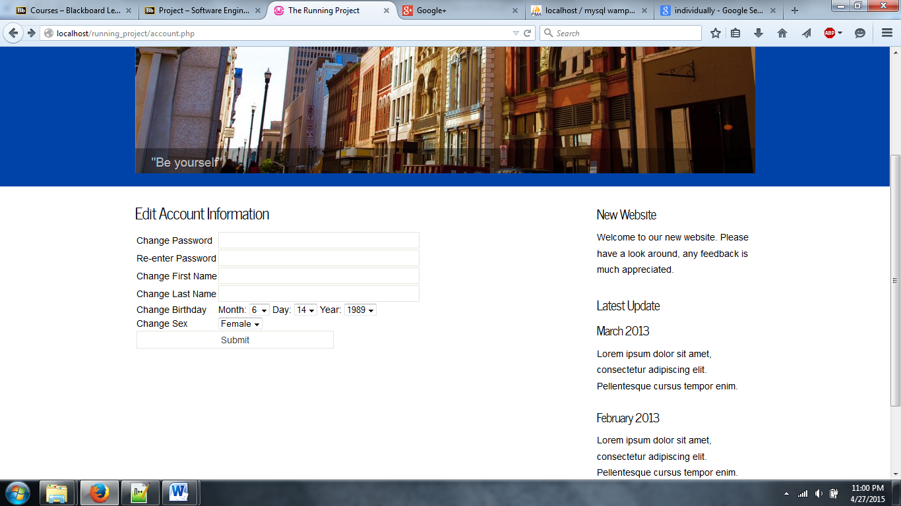

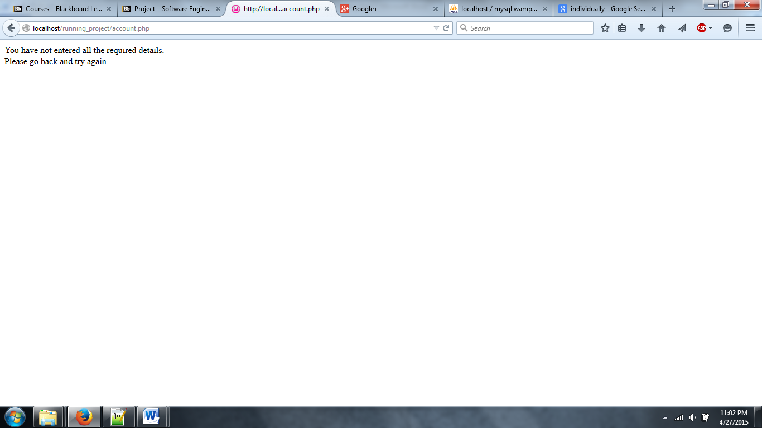

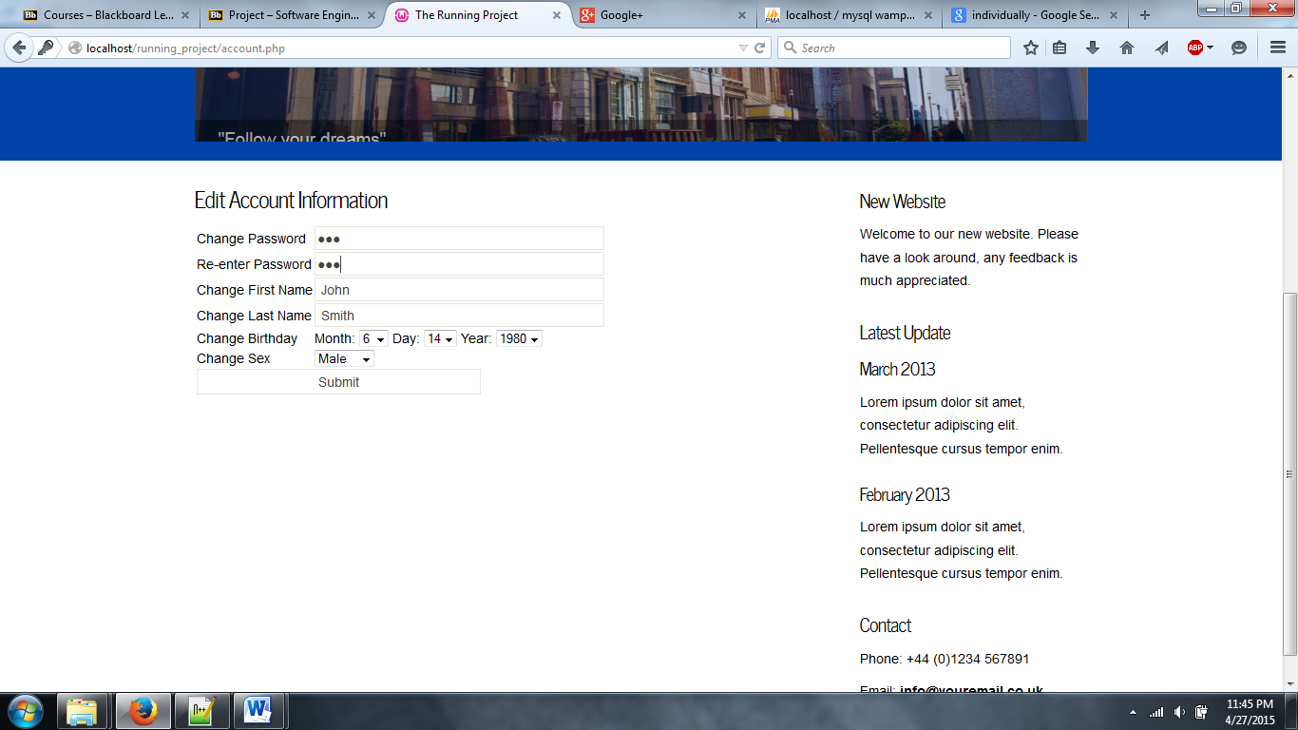

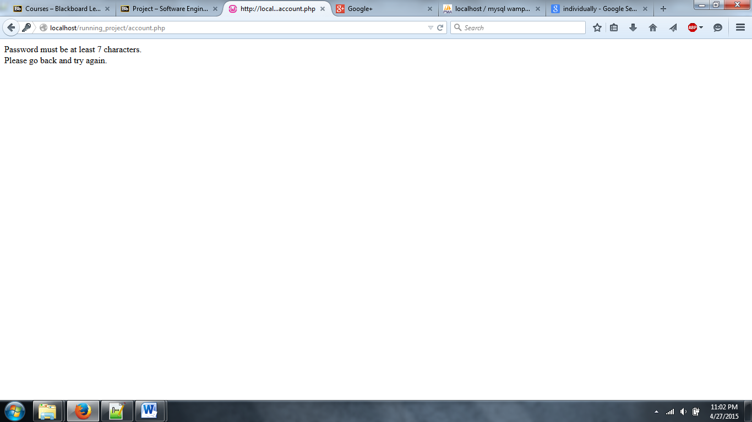

**Submit Race Results**

When testing submitting race results we have to test both the organizer side and the runner side. The organizer can create the race and all the results of registered runners. But the runners can only register. To test this we must make sure when a runner registers for a race it shows up and that each runner can have race results added for them by the race organizer.

Create a race

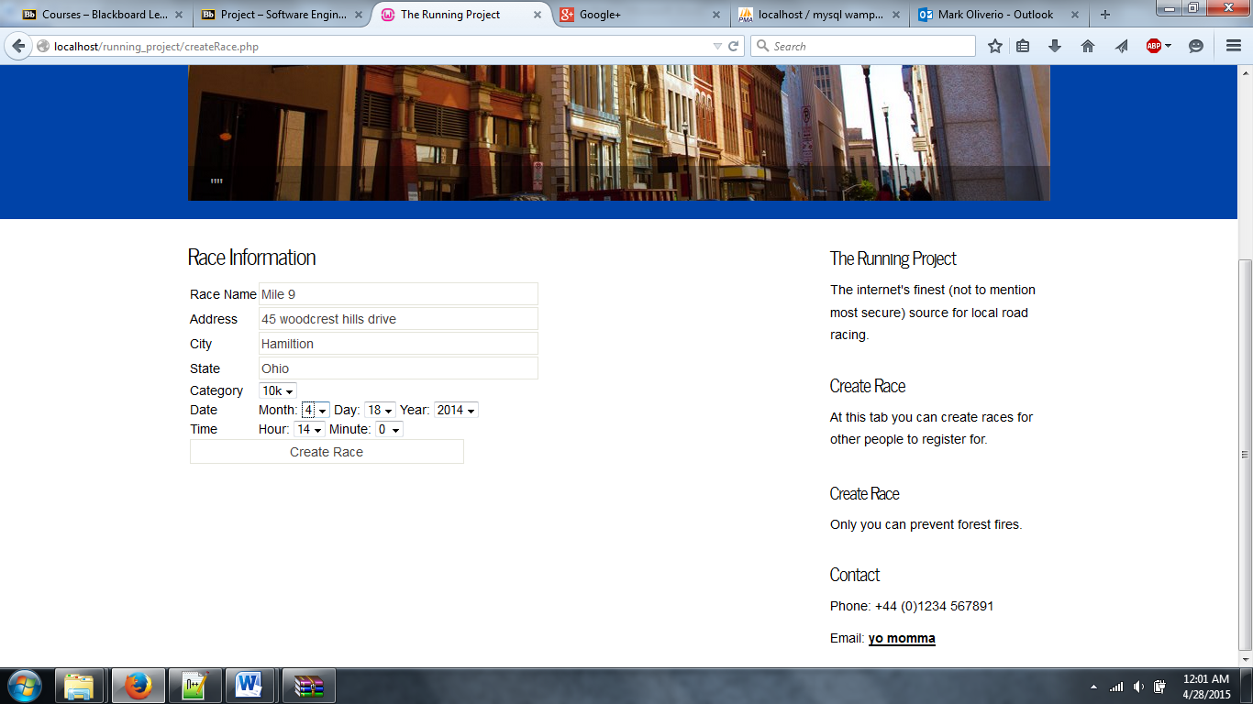

Have a runner register for it

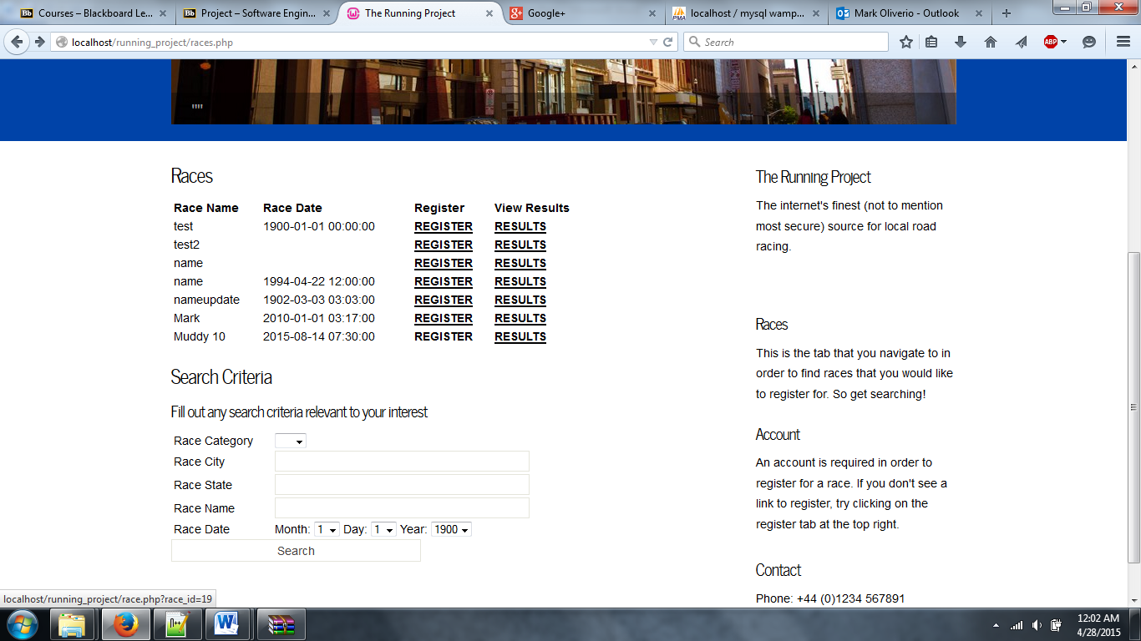

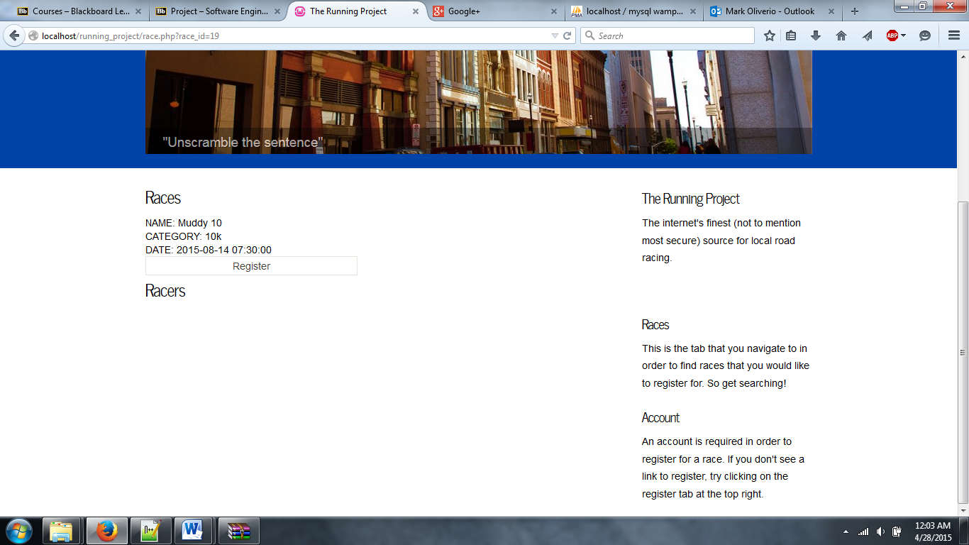

Have the organizer add the result for that racer:

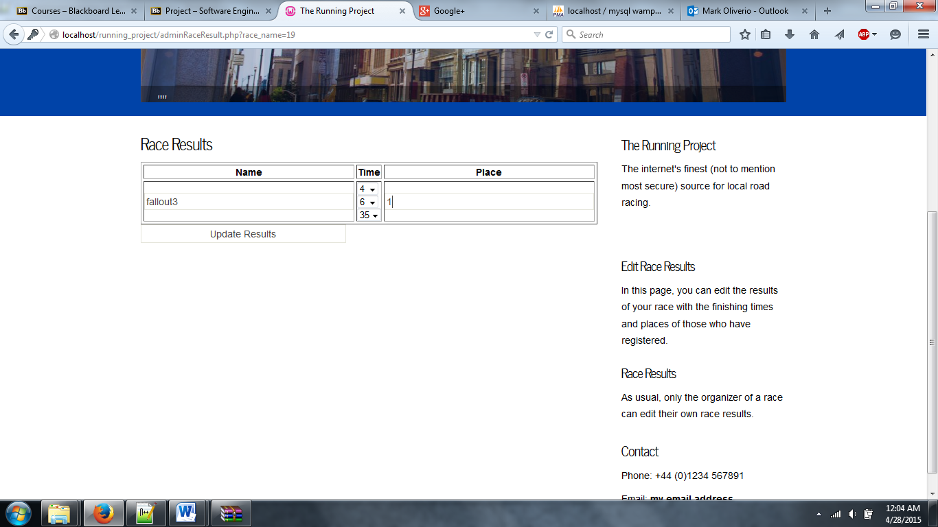

Make sure results are updated:

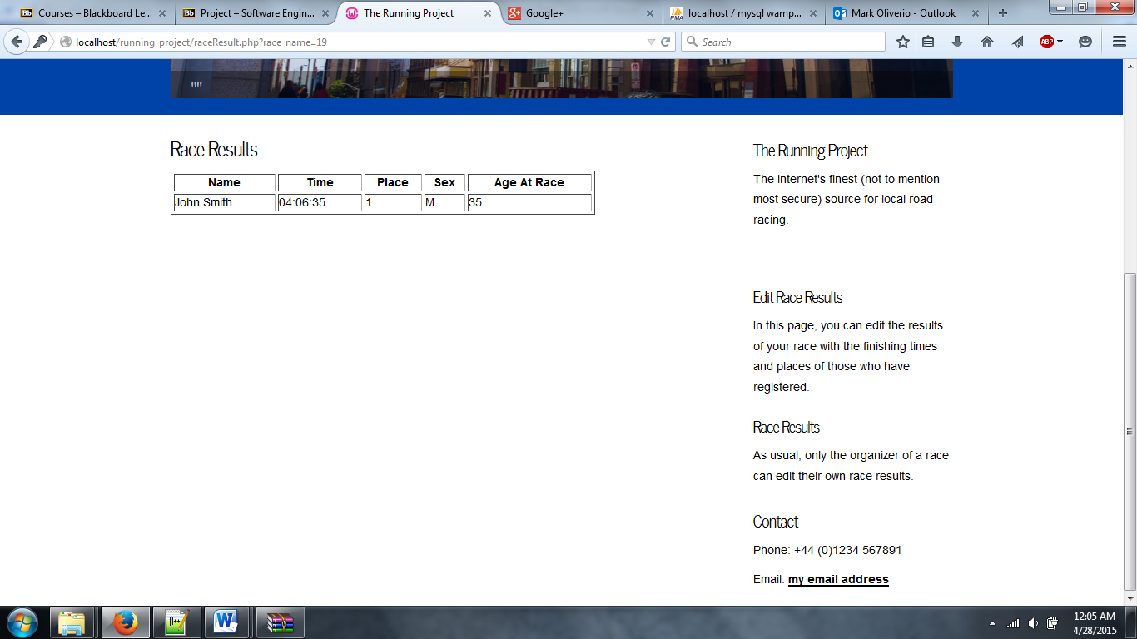

**Modify Race Results**

For this use case you can modify all aspect of the race and its results. Since the actual race result update was already tested in the last use case test, the only thing we need to test is the ability to change the race name, the time the race is at, and its location.

edit that race with new information:

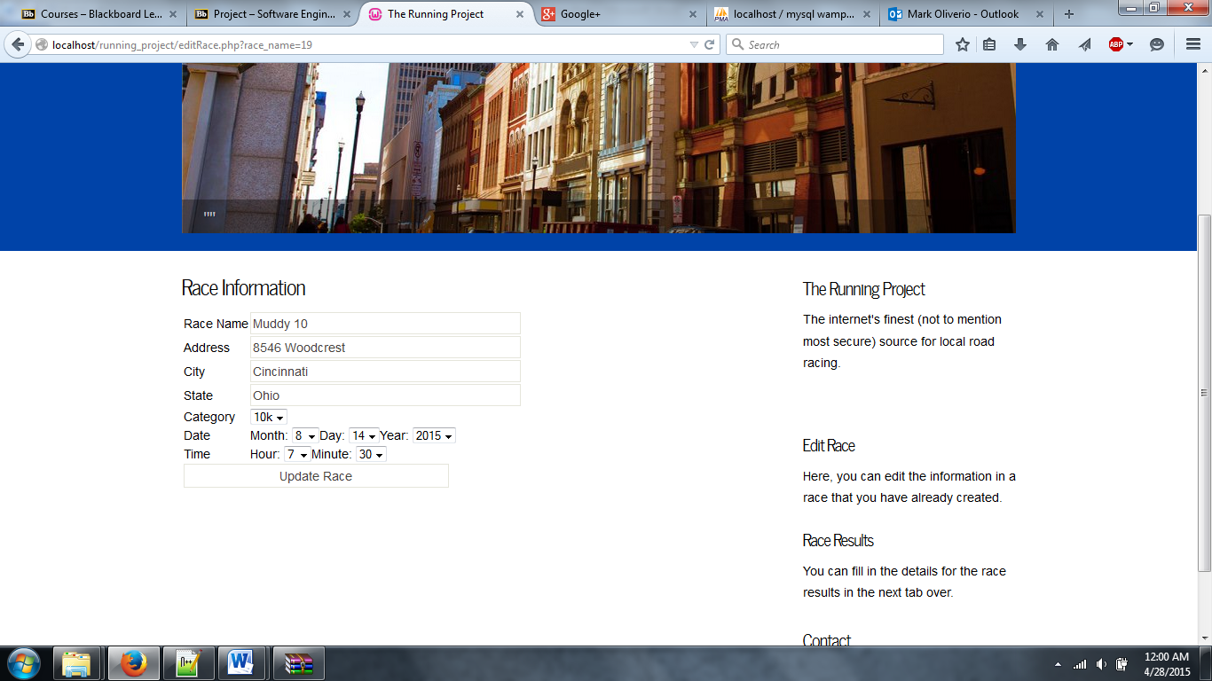

**Search Race Results and runners**

To test the search result we need to test all possible fields to search in an make sure they are giving us the right results.

Search type of race field:

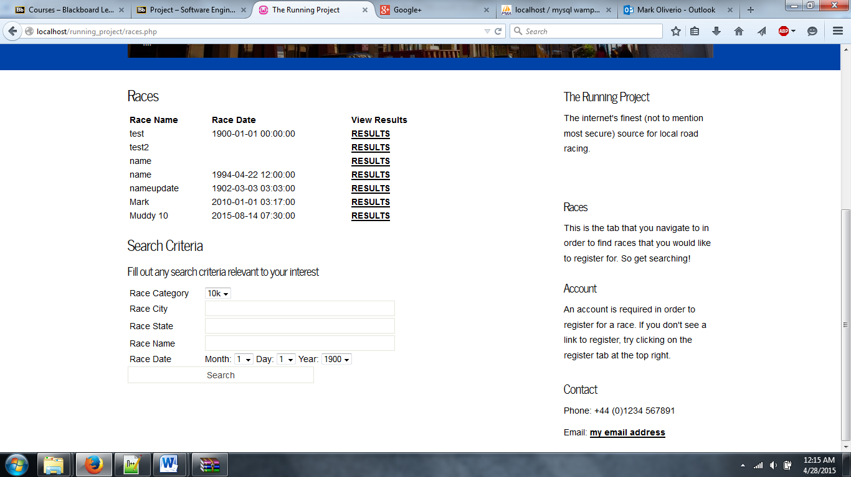

results

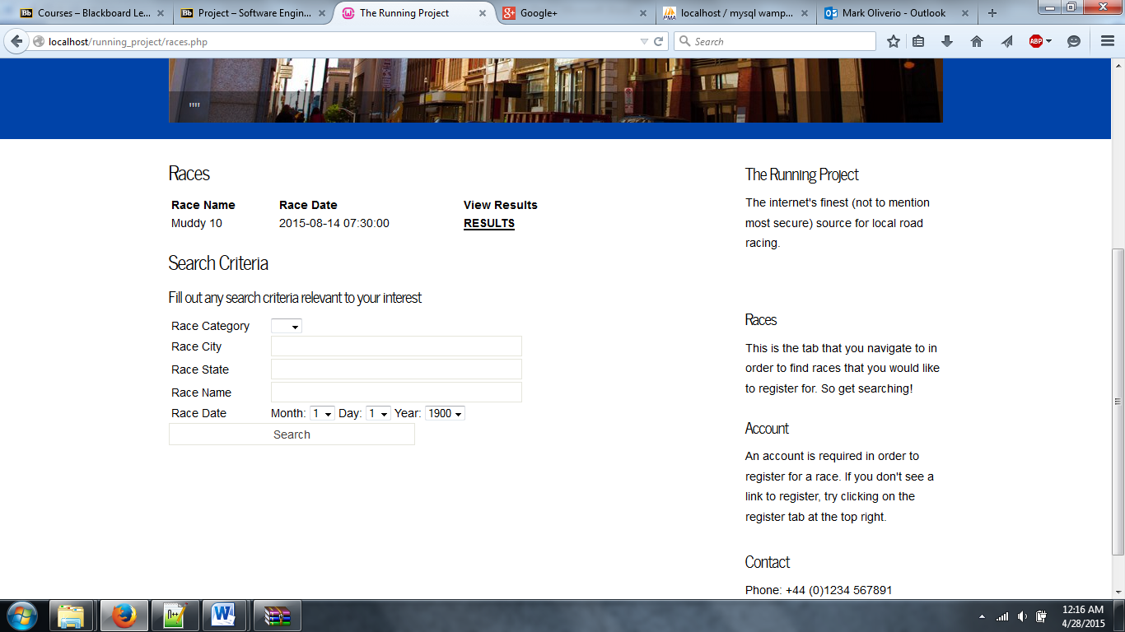

Search race city:

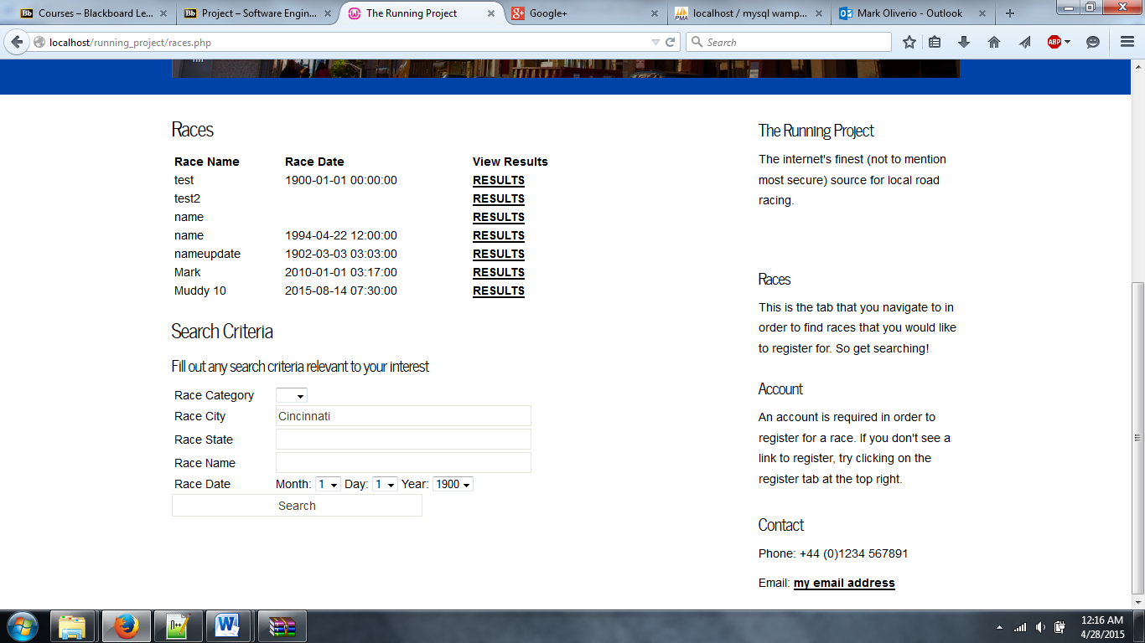

results

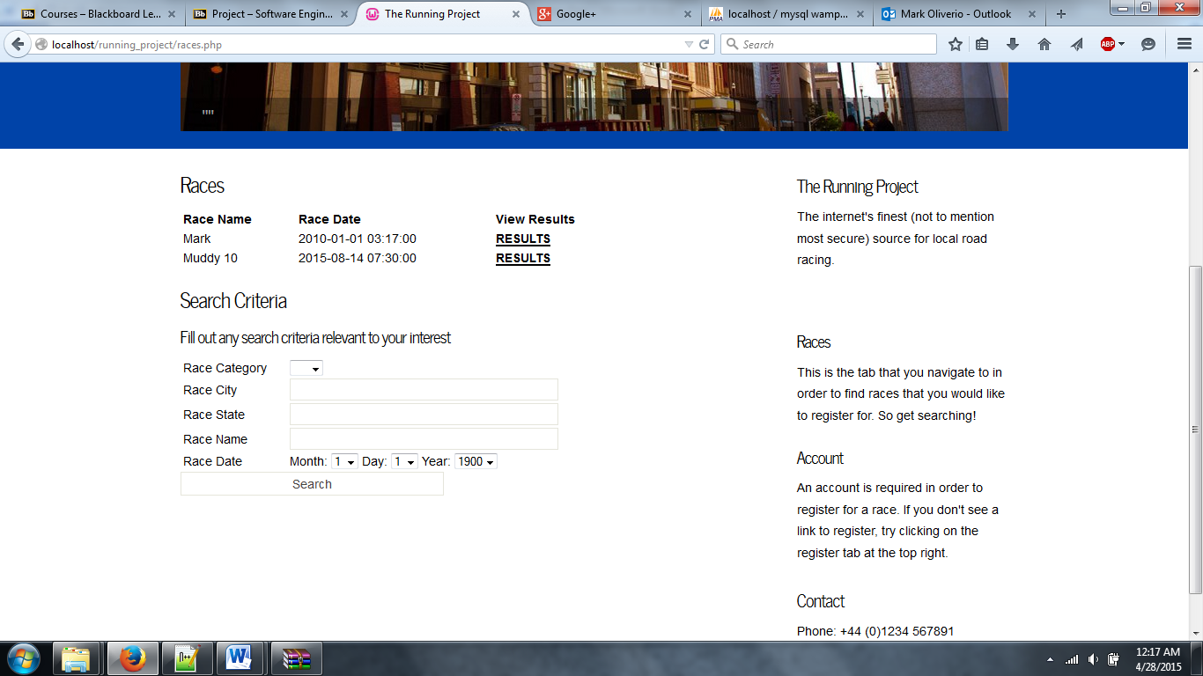

Search state:

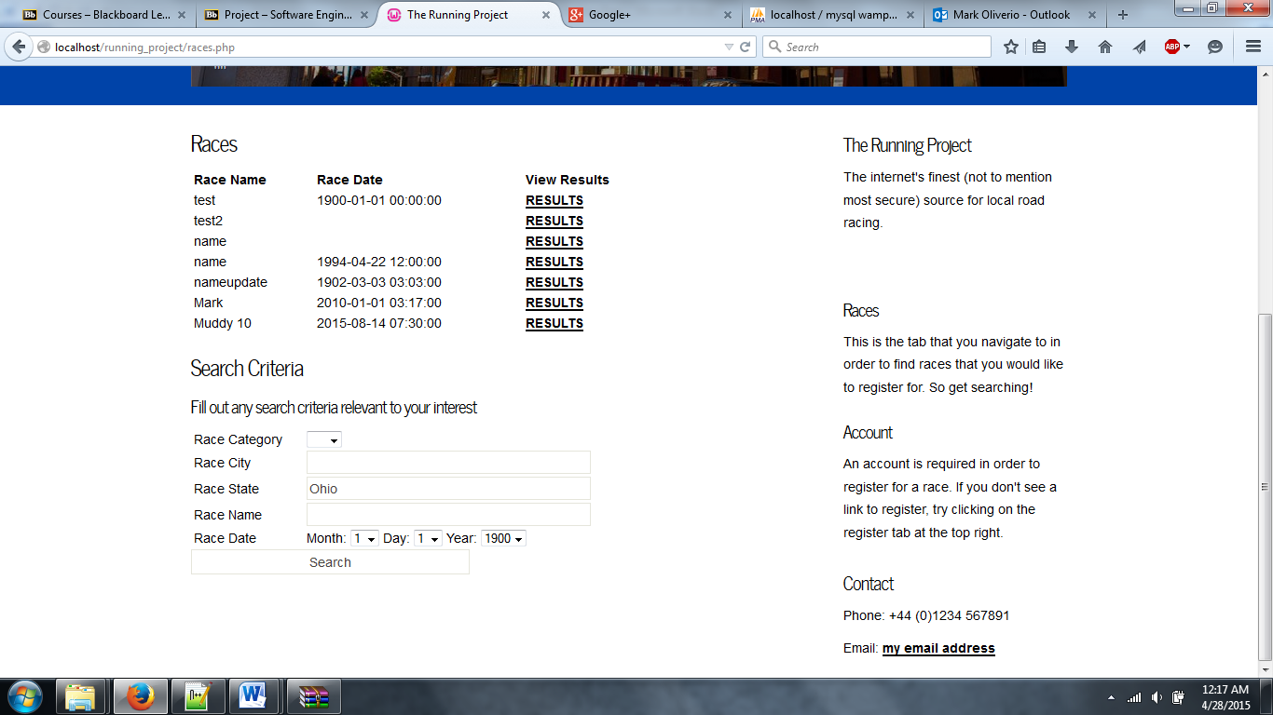

results:

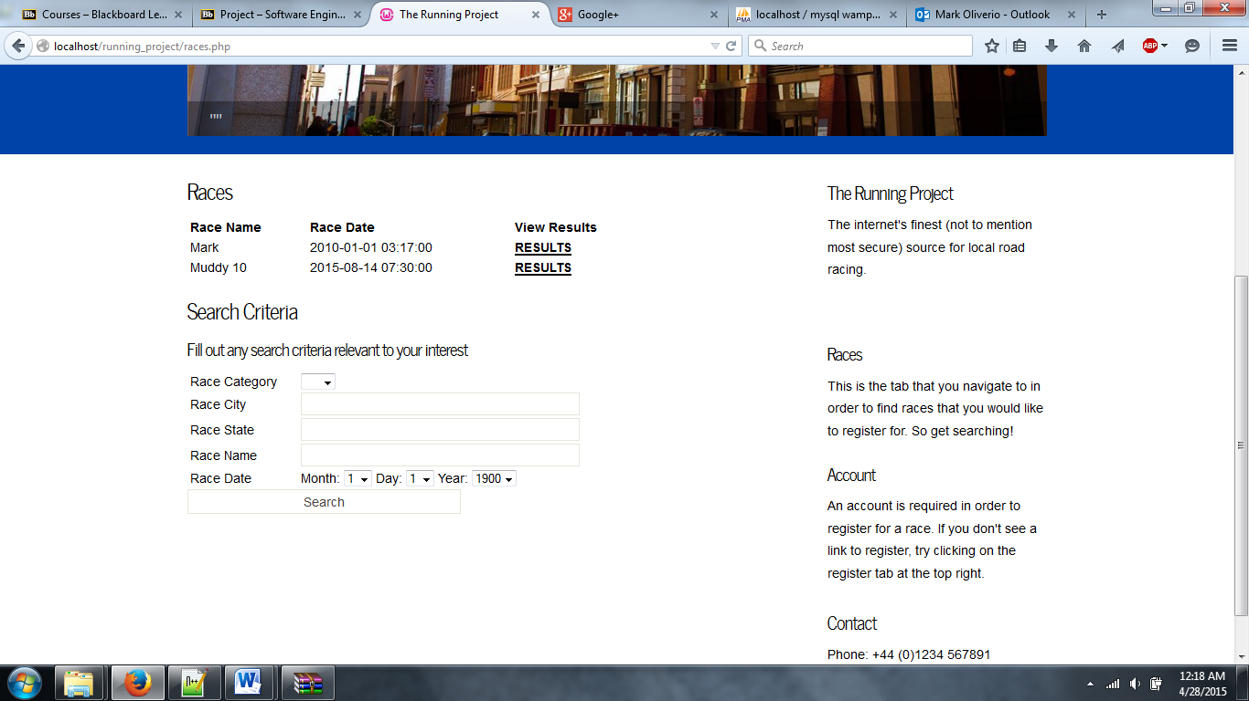

Search race name:

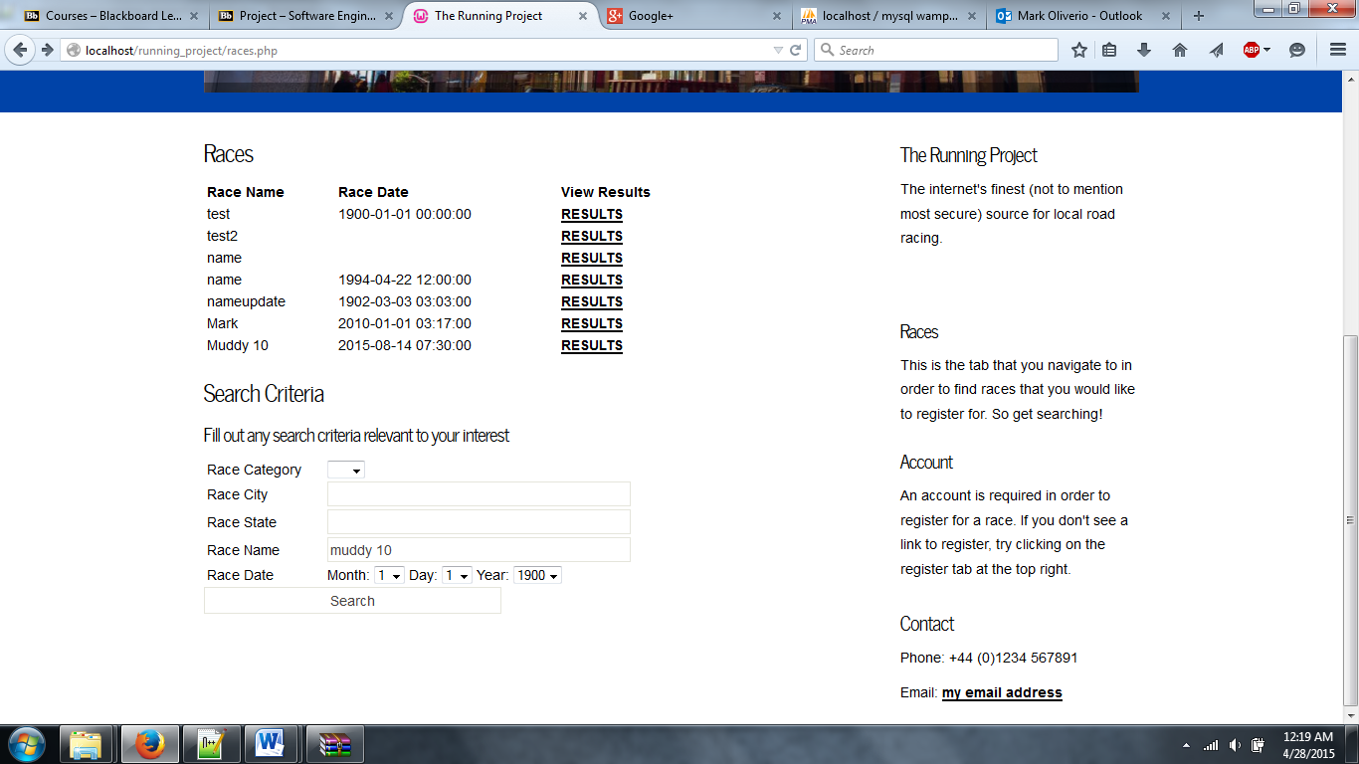

results

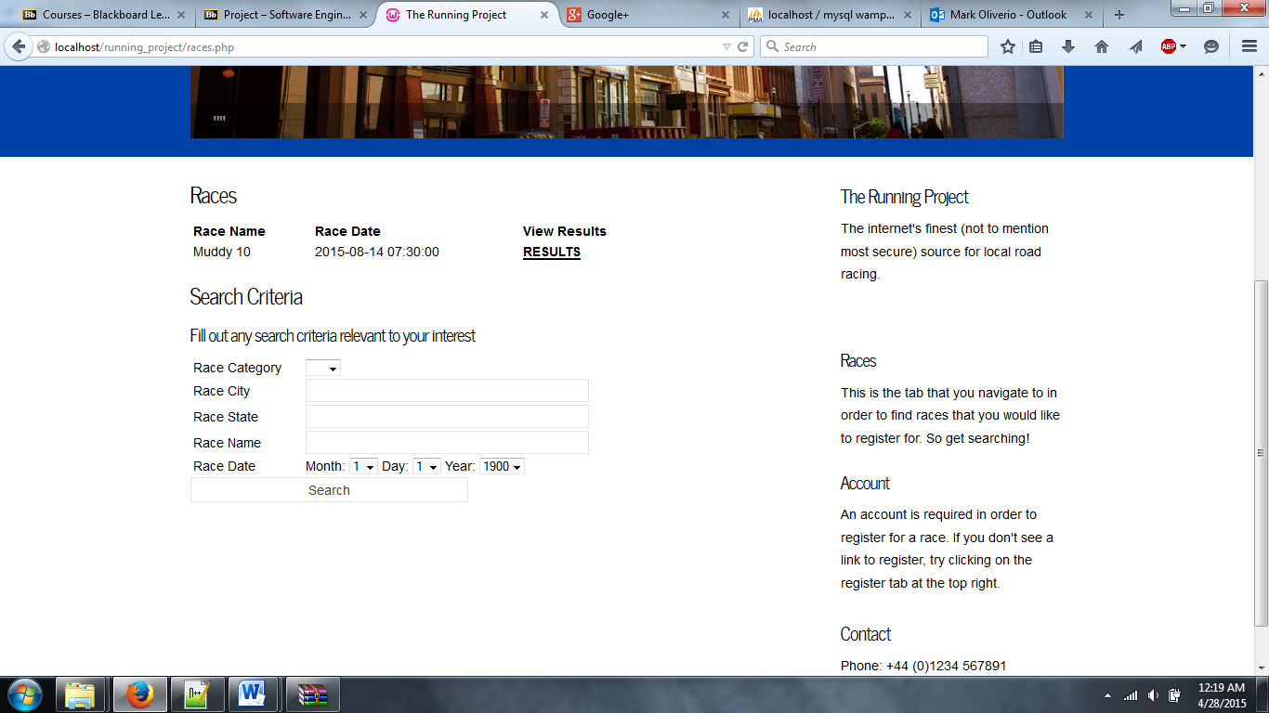

**Filter by Name and age**

To Test the filter by age and sex we simply have to enter in what we want to filter by and make sure it is giving us the right results.

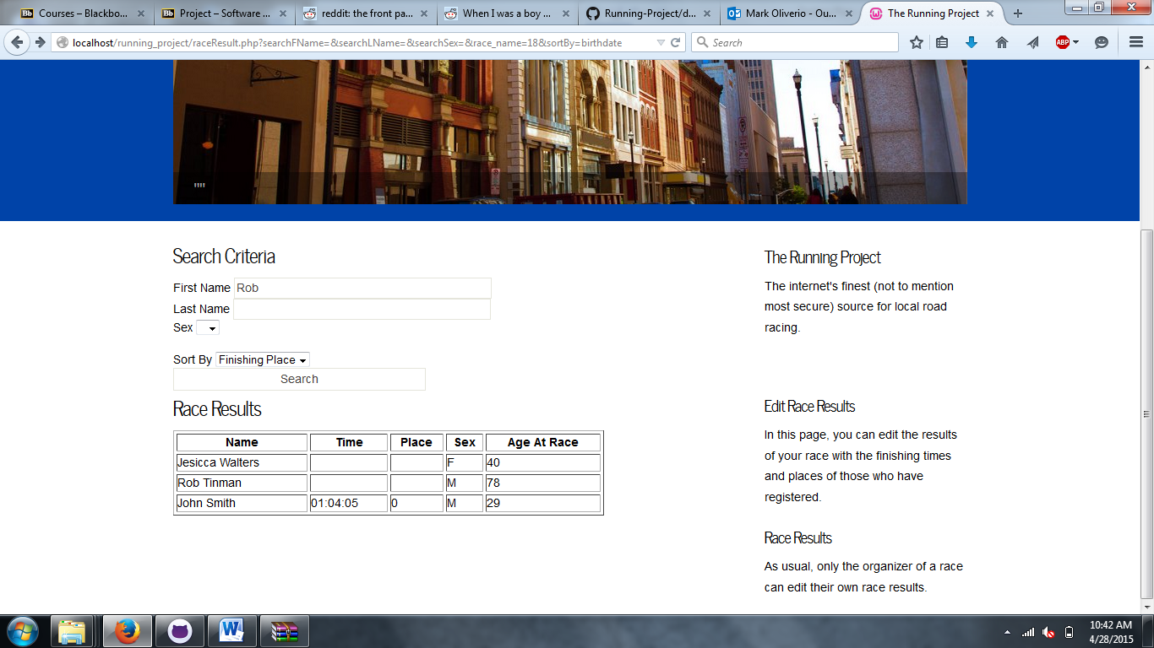

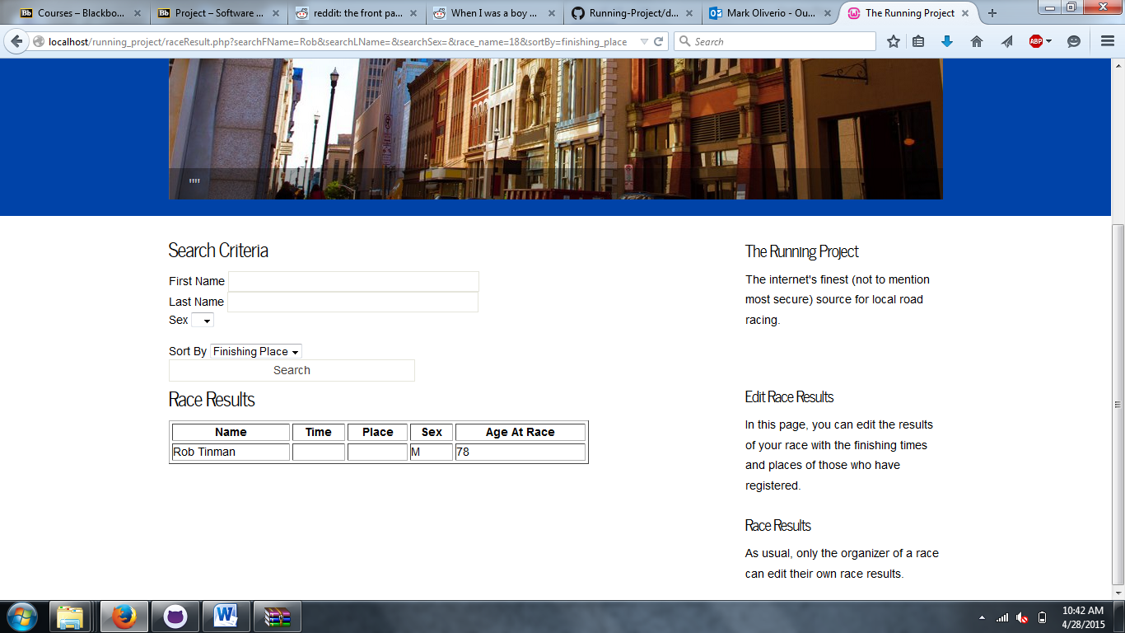

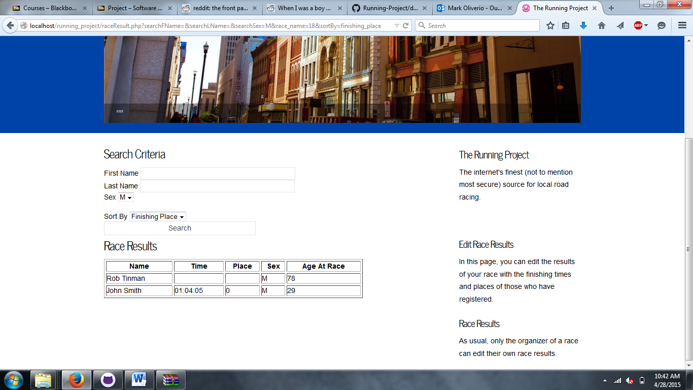

**Sort by Birthdate, sex and finishing position**

To Test the filter by age and sex we simply have to enter in what we want to filter by and make sure it is giving us the right results.

